Statistics Lecture 8.3: Hypothesis Testing for Population Proportion

* For claims involving percentages and proportions.

Requirements:
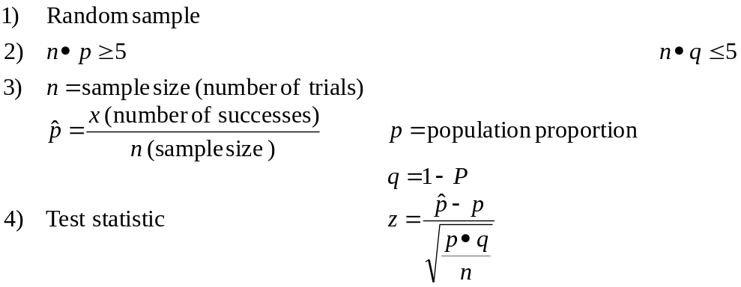

Example
In a sample of 300 corporations, 183 of the CEOs were male.
Test the claim that most CEOs are male. Use a 0.05 significance level.

Step 1 Identify claim and opposite
Claim: 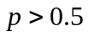
Opposite: 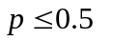

Step 2 Set up Null and alternative Hypothesis.
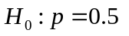
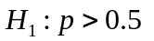

Step 3 Identify Significance Level
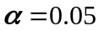
Step 4 Calculate the Test Statistic
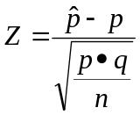
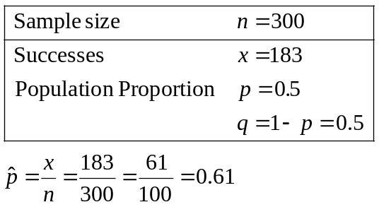

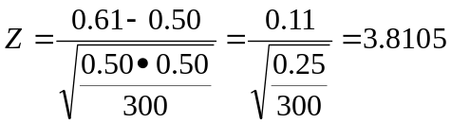

Step 5 Graph

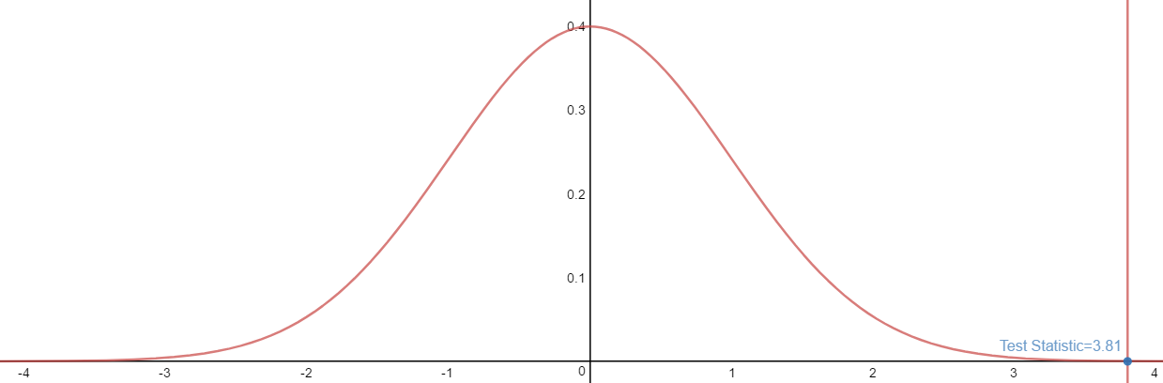
Test statistic = 3.81 (Right tail test)

P-value is the area in the tail(s)
Area= 0.99993
P-value=1-0.99993=0.00007
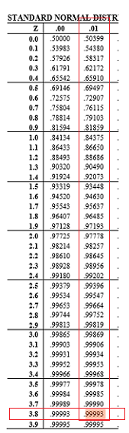
- Make a decision
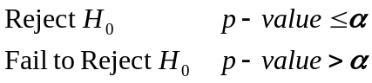
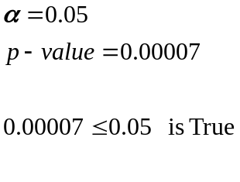
Reject 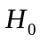 therefore 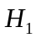 Is true

- Interpret
Reject There is enough evidence to support the claim that most CEO’s are male

Fail to Reject There is not enough evidence to support the claim that most CEO’s are male

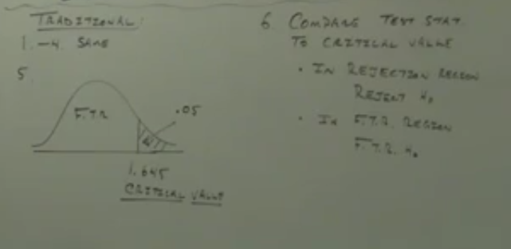

Example
Peas: 428 green pods, 152 yellow pods, use a 0.05 significance level to test the
claim that the proportion of yellow pods is equal to 1/4. (test using p-value)

Step 1 Identify claim and opposite
Claim: 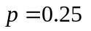
Opposite: 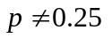

Step 2 Set up Null and alternative Hypothesis.
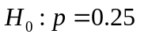
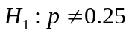

Step 3 Identify Significance Level
two tails
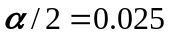

Step 4 Calculate the Test Statistic
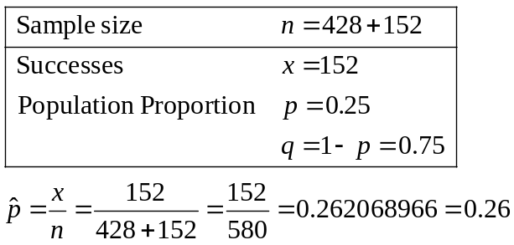

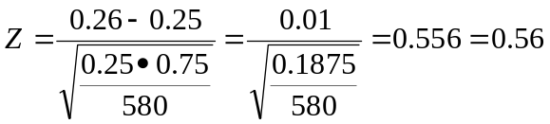
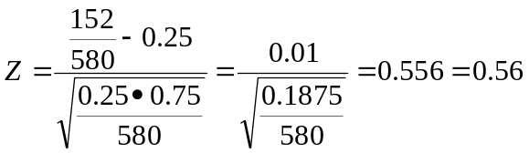

Step 5 graph
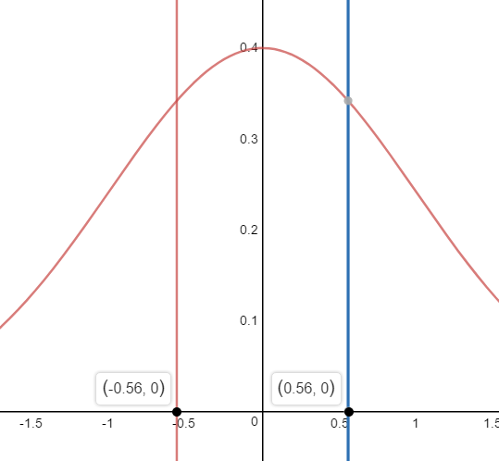
P-value is the area in the tail(s)
Area= 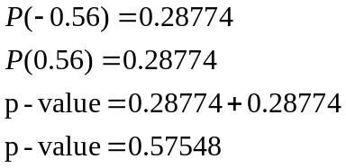

Step 6 Make a decision
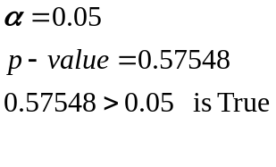
Fail to Reject therefore is unknown

Step 7 Interpret
Fail to Reject There is not enough evidence to support the claim that the proportion of yellow pods is equal to 1/4.
Step 5 graph (Tradition Method

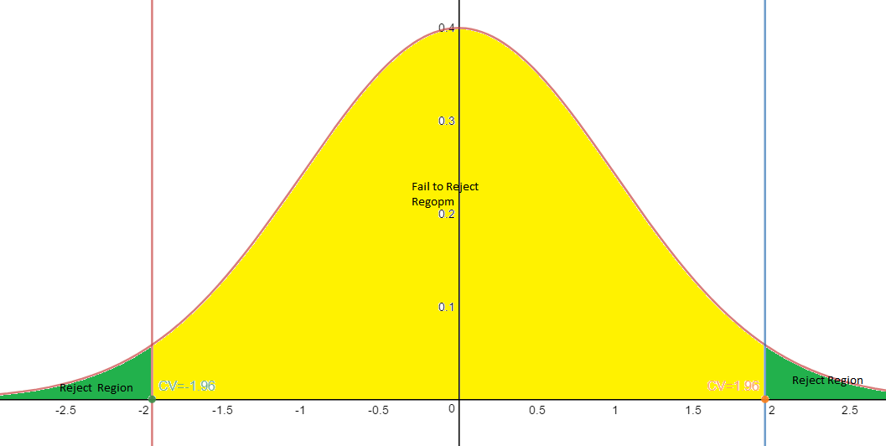
P-value is the area in the tail(s)
Area= 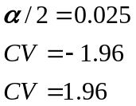

Step 6 Make a decision
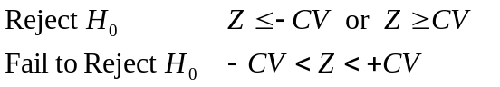
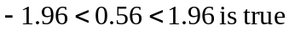
Fail to Reject therefore is unknown

Step 7 Interpret
Fail to Reject There is not enough evidence to support the claim that the proportion of yellow pods is equal to 1/4.

